Friends Women’s Association NOV 2019 2019 Report

Table of Contents
Friends Women’s Association NOV 2019 Report 1
ACTIVITIES 2
Caring for HIV Positive People (CHIVPP) 2
Improving Women’s Reproductive Health (IWRH) 3
Rape Survivors’ Support (RSS) 4
MEDICAL TEAM 6
CONSULTATIONS 6
LABORATORY 6
FAMILY PLANNING 7
PRENATAL CONSULTATION (PNC) 7
ANTI-RETROVIRAL SITE 8
PHARMACY 8
PSYCHOSOCIAL TEAM 8

The section below summarizes the work done during the month of November 2019.
A LEARNING EXPOSURE IN SOUTH SUDAN
Under the support of Nonviolent Peaceforce (NP), a delegation of five people from Quaker Peace Network (QPN) Burundi joined Mel Duncan (Cofounder of NP) for a field exposure in South Sudan from October 29th, 2019 to November 10th, 2019. The purpose was to learn how Unarmed Civilian Protection skills are used on the ground. The result was that we came up with a proposal for the 2020 elections monitoring.

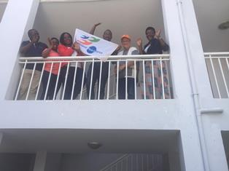

ACTIVITIES

Caring for HIV Positive People (CHIVPP)
During this month of November 2019, medical follow up and home visits were done for our HIV positive people.

Maternity Ward Building
Under the support of the African Great Lakes Initiatives of the Friends Peace teams, we have started building the walls of the second floor. Unfortunately, the funds were finished before they are complete.
The bill of the next steps appears as follows:
- To complete the walls of the second floor, we still need $2600
- frame: $4,000
- 120 Iron Sheets: $2760 (23$/sheet)

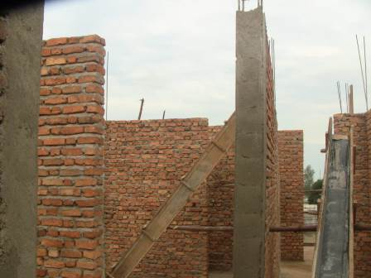

Improving Women’s Reproductive Health (IWRH)
FWA community health workers and FWA staff have continued to educate men, women and young people on the importance of family planning.
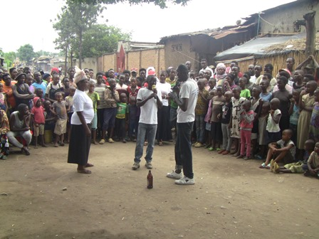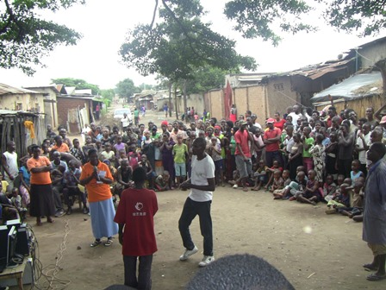
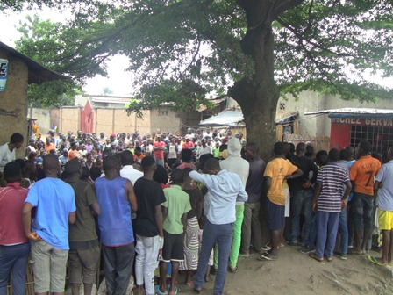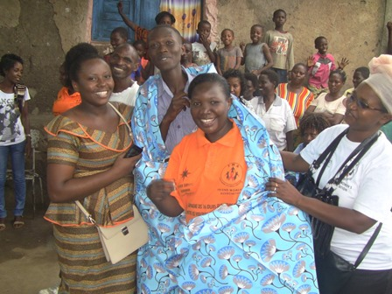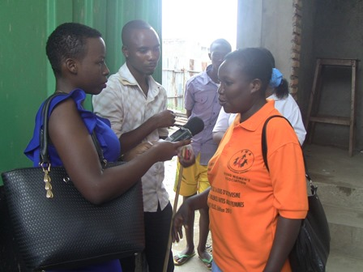
Now, even Medias were invited so that the information can reach more people

Rape Survivors’ Support (RSS
One three-day trauma healing workshop was done on November 28-30, 2019.
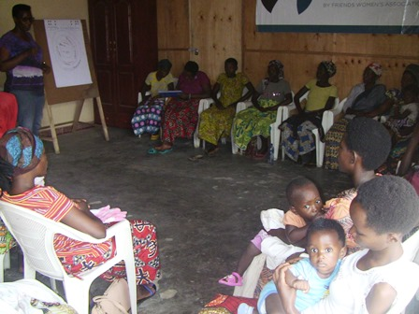
TESTIMONY
My name is Languide. I have been graduated from high school, but I didn’t find a job. As my parents were always quarrelling, I didn’t manage to stay at home in the countryside. I have been jobless for two years. I left home when my father started to attack me complaining that he wasted his money when he paid school fees for a girl. My heart was so heavy because of his words that I fled from home. When I arrived here in Bujumbura, I had already in mind to marry any man I met because of economic problems. Then I got married to a husband who lied to me that he was still single. I got pregnant, and when my delivery date was close, he left me in the house alone. The owner of the house kicked me out because I had no means to pay the rent. I have suffered a lot before I had my baby. Now, I have managed to run small business, and we can survive with my kid.
At the end of November 2019, we had a total of 60 self-help groups for a total of 1415 women
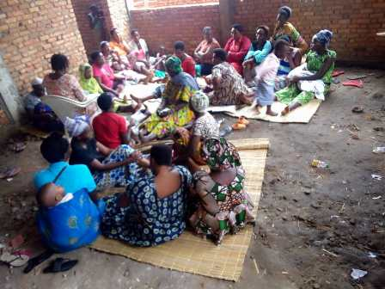

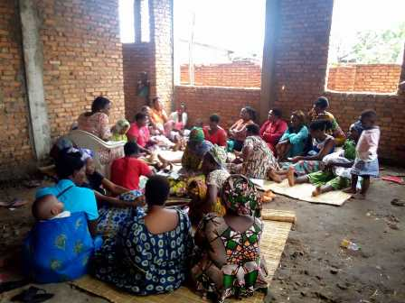
On November 22, 2019 one self-help group whose name is TUGWIZUMWIBU shared their annual benefit. Their capital was BIF 3.573.600. The benefits were BIF1.342.400. Each one received BIF61.000
Action on Gender-Based Violence (AGBV)

During the month of November 2019, three workshops on national rules on families and homes were done for a total of 60 young people.

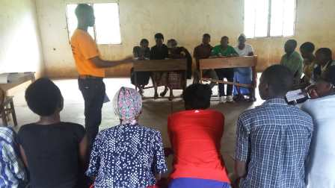

MEDICAL TEAM

CONSULTATIONS
122 cases were consulted by our medical doctors, including 79 adults (48 women and 31 men), 22 children (9 girls and 13 boys) and 21 HIV positive people. The nurse received 267 patients including 191 adults and 76 children.

LABORATORY
In the month of November 2019, apart from HIV voluntary testing, there were a total of 229 tests.
Test | Test completed | Positive | Negative
G.E.  Malaria test | 87 | 38 | 49
Quick malaria test | 11 | 7 | 4
ECBU  Urine test | 8 | 7 | 1
Selles  Stool test | 20 | 19 | 1
Pregnancy | 30 | 12 | 18
Sero-widal  Typhoïd fever | 47 | 27 | 20
Glycémie  Diabetes | 12 | 6 | 6
RPR VDRL  (Syphillis) | 13 | 0 | 13
Complete Blood Count | 1 | 1 | 0
Total Tests: 229

FAMILY PLANNING
360 people received contraceptives from FWA’s nurse, including 246 old cases and 114 new ones. 287 received the contraceptive injection, 29 were given pills, 2 received IUD, 38 received male condoms, and 4 received implant.

PRENATAL CONSULTATION (PNC)
In the month of November 2019, 33 women came for prenatal consultation (PNC), including 10 who came for PNC 1, 11 for PNC 2 and 6 for PNC 3 and 6 for PNC 4
To strengthen our prenatal consultation service, an ultrasound was provided to Ntaseka by John Gould Family Foundation (See attached detailed report)
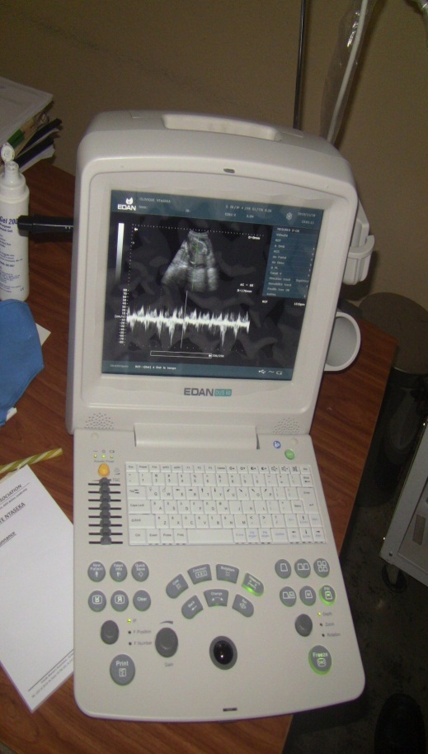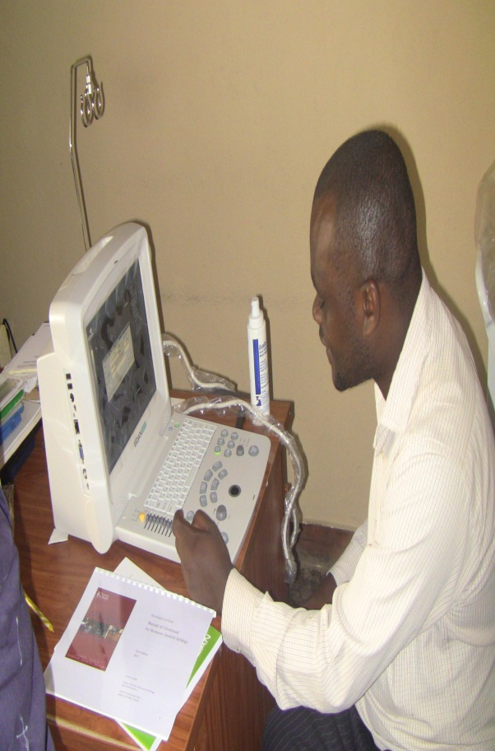

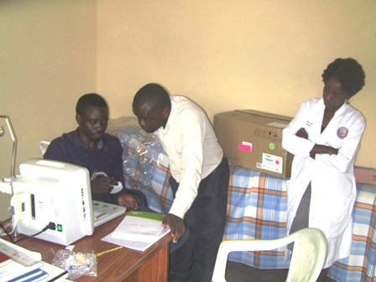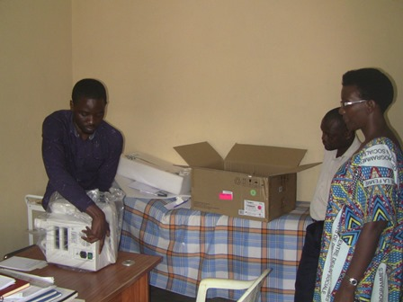

ANTI-RETROVIRAL SITE
At the end of November 2019, we had 330 patients under retro drugs followed at NTASEKA clinic, including 267 women and 63 men.

PHARMACY
Regarding medications, FWA was able to purchase the minimum needed medicine.

PSYCHOSOCIAL TEAM
In the month of November 2019, a total of 60 people received pre and post HIV test counseling and were tested for HIV. Out of the total number, 65% were women and all the four people detected HIV positive were women, with 7% of seropositivity.
Total Number of People Tested: | 60
Total Number of Women Tested: | 39
% of People Tested Who Are Women: | 65%
Average Age: | 29
Median Age: | 28
Total HIV+ : | 4
Total HIV- : | 56
Number of Women HIV+ : | 4
Total % Seropositivity: | 7%
% of Women Tested Who Are HIV+: | 10%

