Friends Women’s Association’s NOVEMBER 2018 Report
The section below summarizes the work done during the month of November 2018.

ADMINISTRATIVE TEAM and Capacity Building
On November 4-8, 2018, Grace HORANIMANA attended the AVP gathering in Uganda.

On November 12-15, Ntahuba Parfaite, the national coordinator of FWA, attended a workshop on the best practices of UCP. This workshop was organized by Nonviolent Peaceforce at Brackenhurst, outside Nairobi, Kenya.
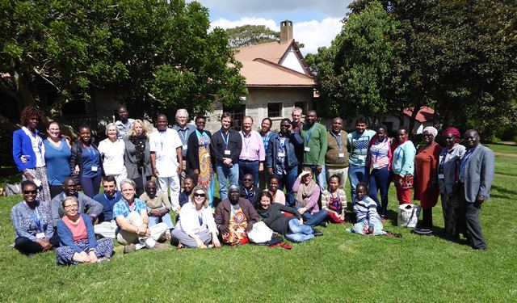

On November 26, there was a Networking Cocktail hosted by SACODE, one of the SFF partners here in Bujumbura, Burundi. The event took place in the gardens of SACODE located on Avenue de France from 6pm-8pm, and all of SFF partners here in Burundi were present. We were joined by Andy Bryant, Executive Director of Segal Family Foundation. It was good time for laughing, relaxing and networking.

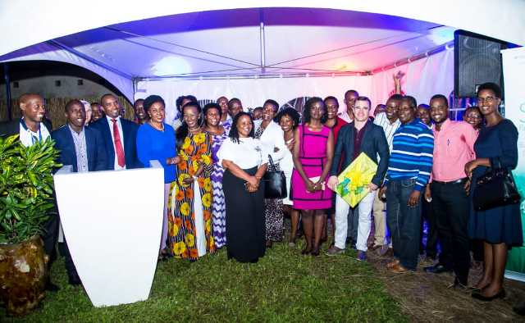

ACTIVITIES
Rape Survivors’ Support (RSS)
On November 21st, 2018, there was one follow up session for 40 people who attended a three-day trauma healing workshop in August 2018.
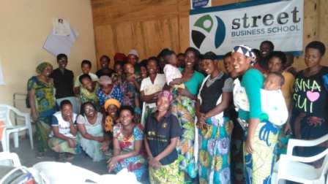

At the end of November 2018, 27 self-help groups were functioning
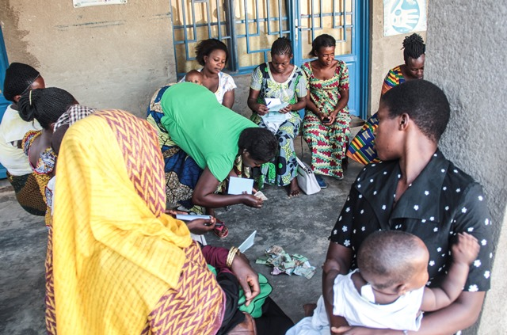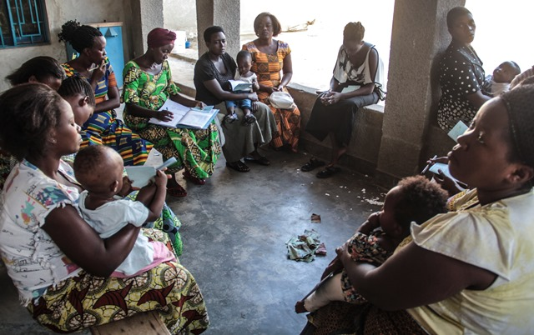

Street Business School
In the month of November 2018, one session on street business was done

Caring for HIV Positive People (CHIVPP)
During this month of November 2018, medical follow up and home visits were done for our HIV positive people.
Through Red Cross Burundi, nutritional support is still provided to our HIV positive beneficiaries. The 2018 annual report was produced.

Maternity Ward Building
In the month of November 2018, we have continued our building project.
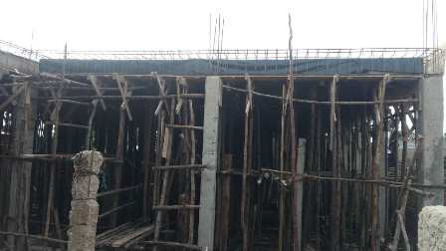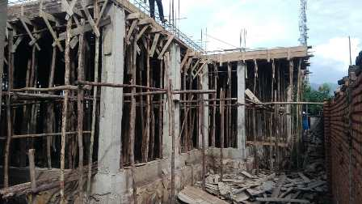
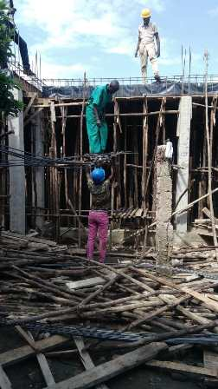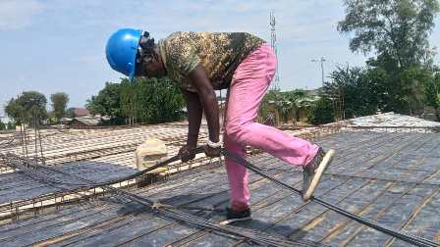
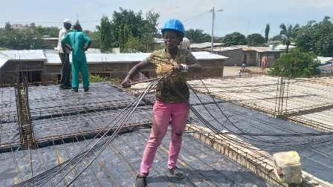
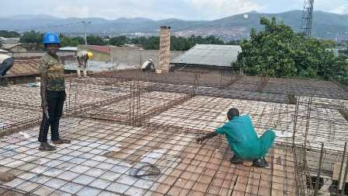
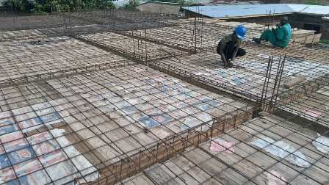
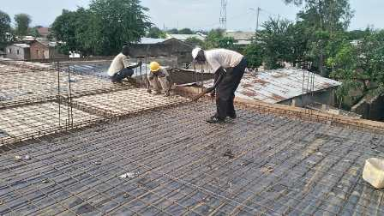

Improving Women’s Reproductive Health (IWRH)
FWA community health workers and FWA staff have continued to mobilize people for HIV voluntary test and family planning.
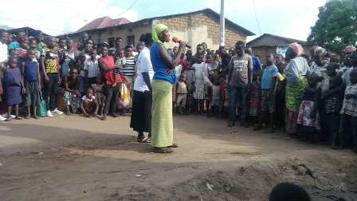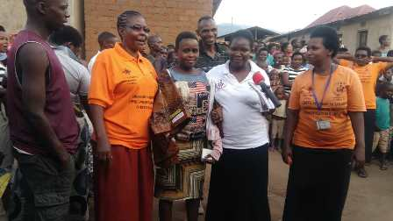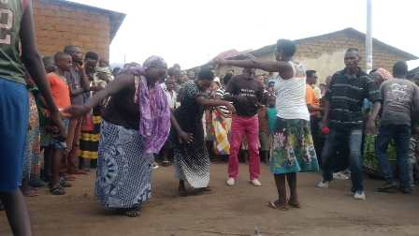
Three discussion groups were organized. Key populations were touched, including partners of HIV positive women, sex workers and drugs’ users.
- Partners of HIV positive women
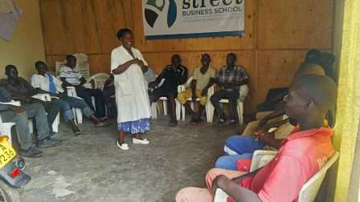
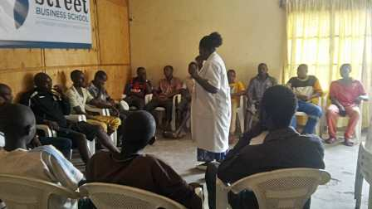
- Sex workers
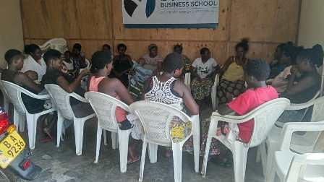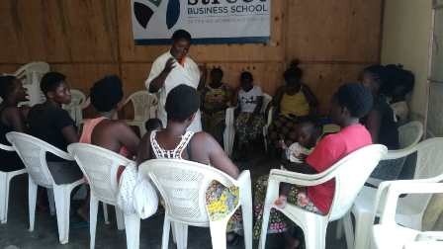
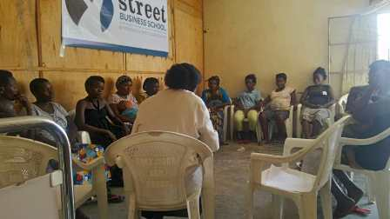
- Drugs’ users
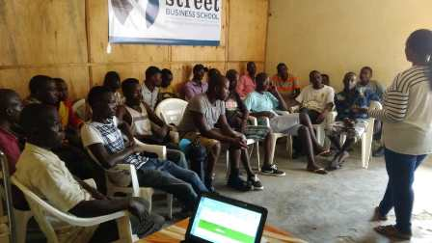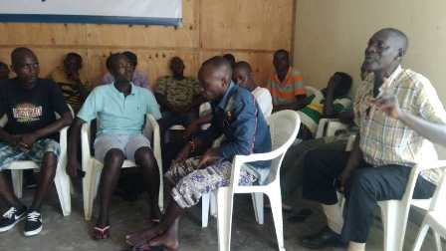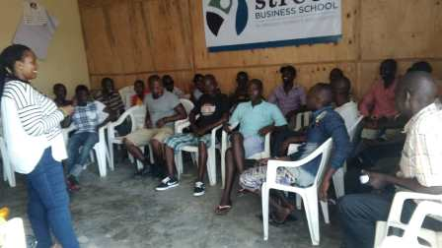

Action on Gender-Based Violence (AGBV)
In the month of November 2018, the campaign of the 16 days of activism against gender-based violence was done.

Medical Team
CONSULTATIONS
149 cases were consulted by our medical doctors, including 26 children, 51 adults and 72 HIV positive people (25 cases were consulted for different pathologies, 12 new cases were diagnosed and put under ARVs treatment, 35 cases for monitoring viral load). The nurse received 343 patients including 245 adults and 98 children.

LABORATORY
In the month of November 2018, apart from HIV voluntary testing, there were a total of 251 tests.

Test | Test completed | Positive | Negative
G.E.  Malaria test | 76 | 22 | 54
Quick malaria test | 3 | 1 | 2
ECBU  Urine test | 11 | 9 | 2
Selles  Stool test | 23 | 22 | 1
Pregnancy | 35 | 11 | 24
Sero-widal  Typhoïd fever | 50 | 39 | 11
Glycémie  Diabetes | 19 | 4 | 15
RPR VDRL  (Syphillis) | 8 | 0 | 8
Complete Blood Count | 26 | - | -
Total Tests: 251

FAMILY PLANNING
310 people received contraceptives from FWA’s nurse, including 201 old cases and 109 new ones. 265 received the contraceptive injection, 32 were given pills, 6 received implants, and 7 received male condoms.

PRENATAL CONSULTATION (PNC)
In the month of November 2018, 31 women came for prenatal consultation (PNC), including 7 came for PNC 1, 10 for PNC 2, 5 for PNC 3 and 9 came for PNC 4.

Anti-Retroviral SITE
At the end of November 2018, we had 281 patients under retro drugs followed at NTASEKA clinic, including 226 women and 55 men.

PHARMACY
FWA had all necessary medicines for the month of November 2018.

PSYCHOSOCIAL TEAM
In the month of November 2018, a total of 217 people received pre and post HIV test counseling and were tested for HIV; 61% of them were women and among the 19 people detected HIV positive, 15 were women with 9% of seropositivity.
Total Number of People Tested: | 217
Total Number of Women Tested: | 132
% of People Tested Who Are Women: | 61%
Average Age: | 27
Median Age: | 26
Total HIV+ : | 19
Total HIV- : | 198
Number of Women HIV+ : | 15
Total % Seropositivity: | 9%
% of Women Tested Who Are HIV+: | 11%

