FWA MAY 2017 Report
The section below summarizes the work done during the month of May 2017.
ADMINISTRATIVE TEAM

On May 23, 2017, Pastor NTAHUBA Parfaite, FWA coordinator, came back from Canada. There attended a two-week training on Unarmed Civilian Peacekeeping (UCP) at Selkirk College, Nelson Tenth Street Campus, British Columbia in Canada. Parfaite comes back with UCP skills that will surely help in a practical way in her leadership as a both one of the three women pastors from the Evangelical Friends church of Burundi and FWA coordinator. UCP principles (Nonviolence, nonpartisanship, independency, transparency, primacy for local people) and strategies (Proactive presence, Building relationships, capacity building and monitoring) might also so relevant in Burundi especially when it comes to elections. Thanks a lot to the Mircentre for Peace at Selkirk College who has supported FWA coordinator flight as well as her stay in Canada.

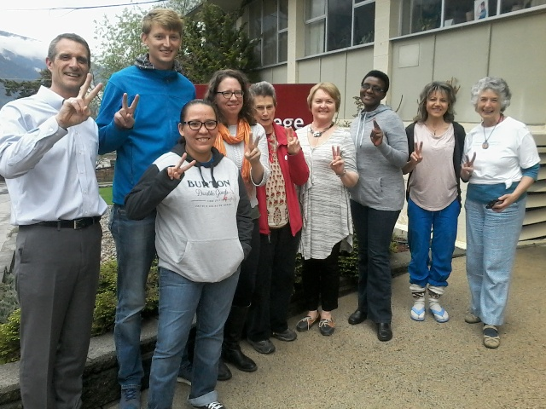

A group photo after the training: from left: the president of the Mircentre for peace, Ian from Germany, Sabrina (A first nation woman working for restorative justice), Teeka (A nurse at Trail Hospital), Pegasus (A community leader in Nelson), Olga (Working at Selkirk College), Parfaite (From Burundi), Nadine (A community leader) and Madelyn Mackay (One of our UCP teachers)

During the same visit, FWA coordinator was able to visit Vancouver Island monthly meeting as well as to attend the Western Half-yearly Meeting held in Sorrento where she was given opportunities to share about FWA programs. Vancouver Island monthly meeting is once again committed to support FWA Caring for HIV Positive people program, and they are even now sensitizing other Canadian Quaker monthly meetings to join them in supporting FWA. Let us underline that after listening and watching FWA short videos, the Canadian Friends Service Committee (CFSC) is engaged to find more ways to support our programs.
ACTIVITIES
During the month of May 2017, the activities done were about READY, RSS, CHIVPP and IWRH projects.
READY
As part of the READY project, different services were offered in the following logic:

56 teenagers from the target group, including 29 female and 27 male, underwent voluntary testing and received information about HIV/AIDS through pre and post-test counseling. We had 12 young female people from the target group (age between 10 and 19 years) for family planning and related information.110 young people were given information on sexual and reproductive health, and 480 condoms were distributed to young people.

Rape Survivors’ Support (RSS)
Two self-help groups are now functioning. On 25-27 May, 2017, there was one three-day trauma healing workshop for a group of male people.
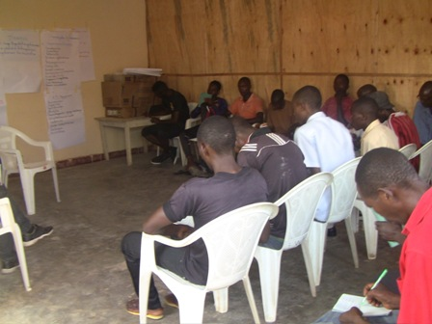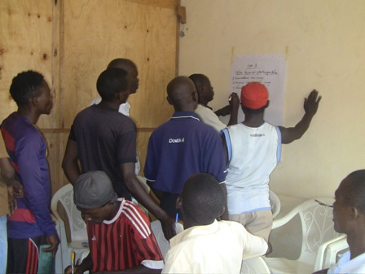
Caring for HIV Positive People (CHIVPP)
During this month of April 2017, medical follow up and home visits were done for our HIV positive people. They also received nutritional support. Two discussion groups were also done. The self-help group has now a capital of BIF200,000.
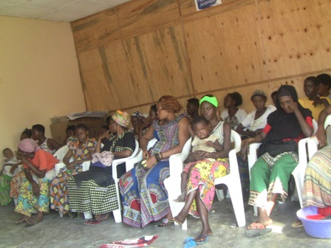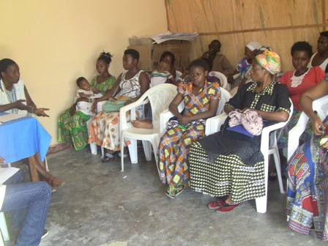

Improving Women’s Reproductive Health (IWRH)
FWA health accompanists together with FWA staff have continued to sensitize people to attend NTASEKA clinic for birth control and HIV voluntary test.
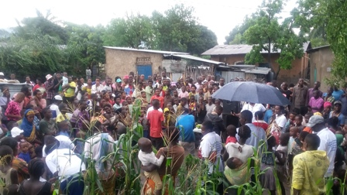
Marie Claire KAMUGISHA, the respondent of the project, sensitizing Kamenge community for birth control
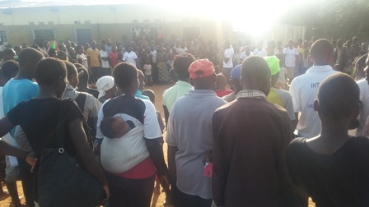

Action on Gender-Based Violence (AGBV)
The Quaker Service Norway (QSN) has agreed to give a grant of 9,500USD for this year program.

Medical Team
CONSULTATIONS
17 cases were consulted by our doctor. The nurse received 246 patients including 147 adults and 99 children.
The same month, May 15-19, 2017 there was also a vaccination campaign for children. All of them received measles and rubella vaccin. The results were the following:
- 476 children between 6-11 months
- 989 children between 12-59 months
- 1382 children between 5-9 years
- 1253 children between 10-14 years

From the above, it is clear that a total number of 4100 children was achieved
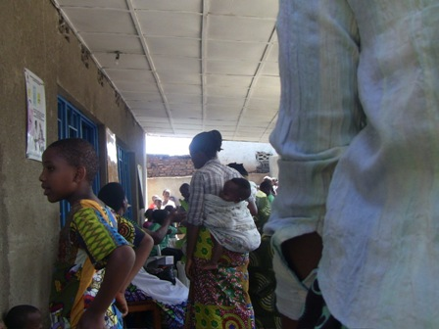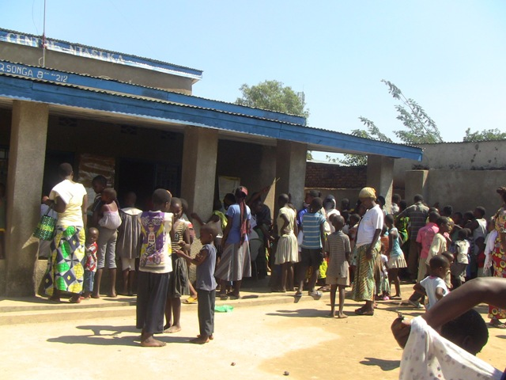
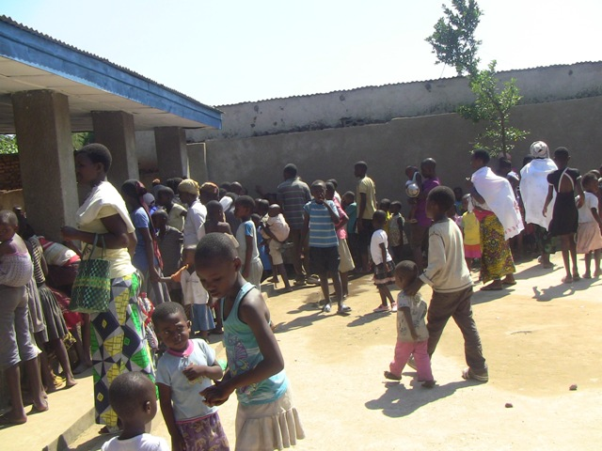

LABORATORY
In the month of May 2017, apart from voluntary testing, there were a total of 181 tests.

Test | Test completed | Positive | Negative
G.E. | 93 | 24 | 69
Selles | 23 | 23 | 0
ECBU | 3 | 1 | 2
Pregnancy | 18 | 3 | 15
Sero-widal  (Typhoïd fever) | 41 | 33 | 8
Glycémie | 3 | 1 | 2
Complete Blood Count (CBC) | 0 | - | -
Total Tests: 181

FAMILY PLANNING
231 women received contraceptives from FWA’s nurse. 182 received the contraceptive injection, 14 were given pills and 35 received male condoms.

PRE-NATAL CONSULTATION
Three women came for the pre-natal consultation.

ARV SITE
At the end of May 2017, we had 134 patients under retro drugs followed at NTASEKA clinic, including 112 women and 22 men.

PHARMACY
FWA had all necessary medicines for the month of May 2017.

PSYCHOSOCIAL TEAM
In the month of May 2017, a total of 165 people received pre and post HIV test counseling and were tested for HIV; 56% of them were women and among the 9 people detected HIV positive, six of them were women with 5% of seropositivity.

Total Number of People Tested: | 165
Total Number of Women Tested: | 93
% of People Tested Who Are Women: | 56%
Average Age: | 24
Median Age: | 23
Total HIV+ : | 9
Total HIV- : | 156
Number of Women HIV+ : | 6
Total % Seropositivity: | 5%
% of Women Tested Who Are HIV+: | 7%

