Friends Women’s Association’s JUNE 2018 Report
The section below summarizes the work done during the month of June 2018.
ADMINISTRATIVE TEAM
On June 1, 2018, Liana NZABAMPEMA, the Segal Family Foundation representative in Afrique Francophone, visited FWA to evaluate together how we are doing to achieve our 2018 milestones.
On June 23-30, 2018, Bertha Small, a medical doctor and the clerk of the Peace Committee at the Canadian Friends Service Committee (CFSC) visited FWA to see the work we are doing on the ground.

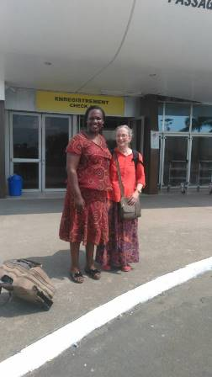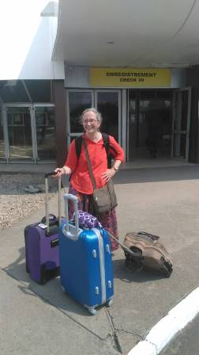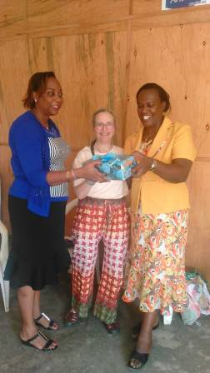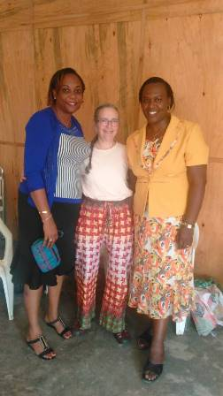
Bertha Small with some of FWA legal representative and her vice
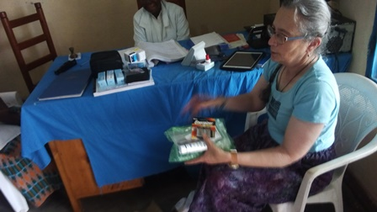
Bertha Small giving some medical supplies to FWA medical team

ACTIVITIES
Rape Survivors’ Support (RSS)
At the end of June 2018, 16 self-help groups were functioning. RSS is still supported by the African Great Lakes Initiatives (AGLI).
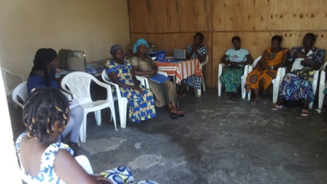

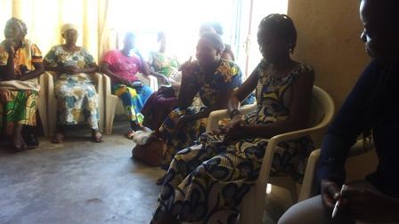
Two trauma healing workshops for Gender Based Violence survivors were done.
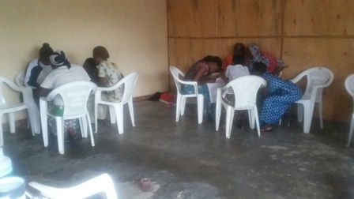
Small groups during a three-day trauma healing workshop
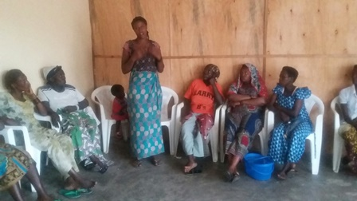

Caring for HIV Positive People (CHIVPP)
During this month of April 2018, medical follow up, nutritional support and home visits were done for our HIV positive people. One discussion group was done on April 5th, 2018. This program is supported by Vancouver Island Monthly Meeting.
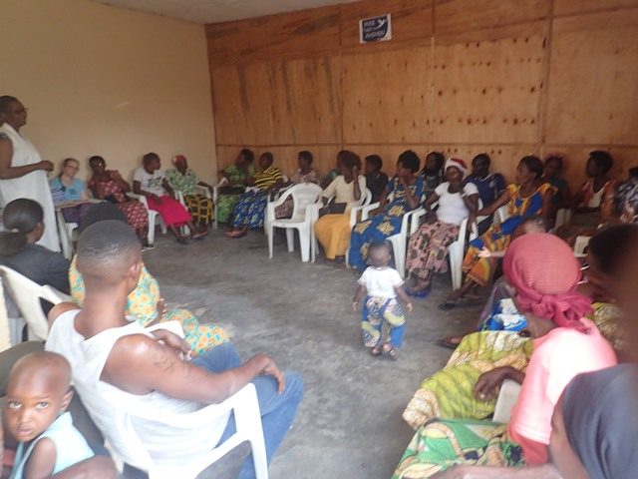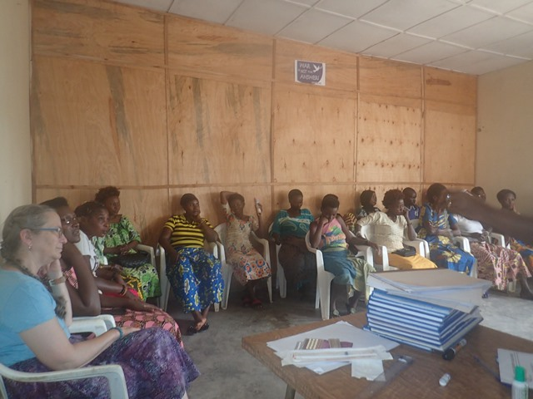

Improving Women’s Reproductive Health (IWRH)
One clinic mobile was done on June 26, 2018. A total of 200 people came for HIV voluntary test, including 34 women and 166 men.

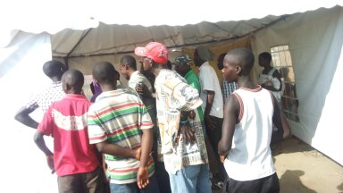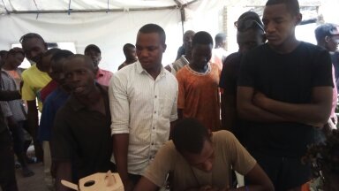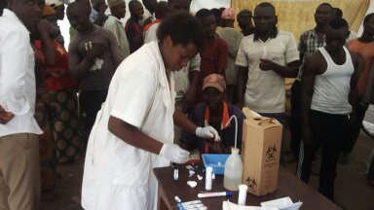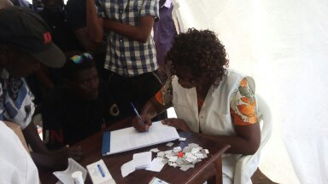

Action on Gender-Based Violence (AGBV)
In the month of June 2018, one GBV basic workshop was done in Giheta commune, Gitega province. We had a total of 20 participants, including 10 religious leaders and 10 community elected leaders.
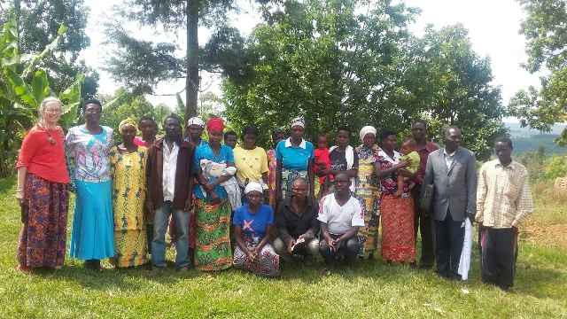

On June 29, 2018, GBV facilitators from Kibimba organized a special day to raise awareness against GBV
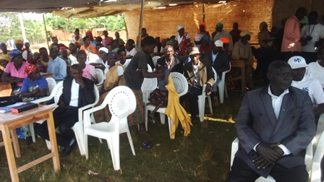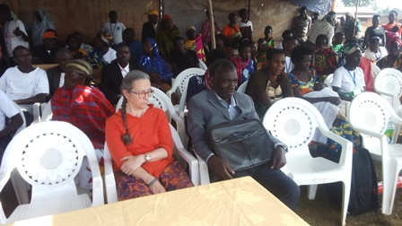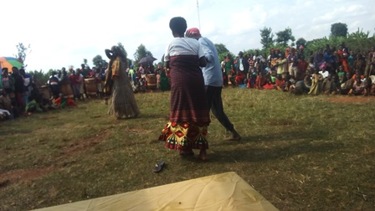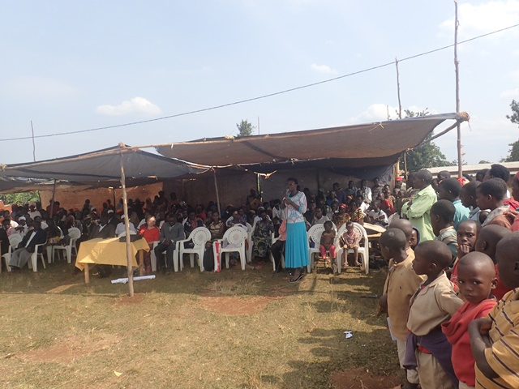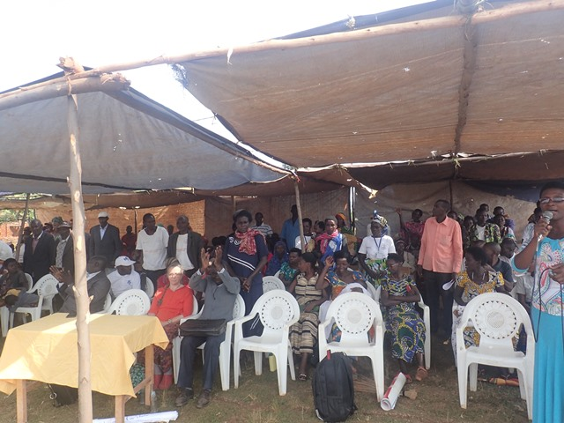

Medical Team
CONSULTATIONS
57 cases were consulted by our medical doctors, including 18 children, 15 adults and 24 people under ARVs treatment. The nurse received 359 patients including 268 adults and 91 children.

June 19-22, 2017 was a special week for the health of both the mother end the child. So, there was a vaccination campaign for children and pregnant women at the national level. NTASEKA clinic was one of the selected places to do the vaccination. The details are the following:
- 1864 children between 6-59 months received Vitamin A
- 2894 children between 1-14 years received Albendazole
- 283 pregnant women were given both Albendazole and soaps

From the above, it is clear that a total number of 4758 children and 283 pregnant women was achieved

LABORATORY
In the month of June 2018, apart from HIV voluntary testing, there were a total of 302 tests.

Test | Test completed | Positive | Negative
G.E.  Malaria test | 117 | 34 | 83
Quick malaria test | 3 | 0 | 3
ECBU  Urine test | 5 | 4 | 1
Selles  Stool test | 26 | 23 | 3
Pregnancy | 56 | 18 | 38
Sero-widal  Typhoïd fever | 38 | 28 | 10
Glycémie  Diabetes | 19 | 8 | 11
RPR VDRL  (Syphillis) | 17 | 3 | 14
Complete Blood Count (CBC) | 21 | - | -
Total Tests: 302

FAMILY PLANNING
343 people received contraceptives from FWA’s nurse, including 206 old cases and 137 new ones. 276 received the contraceptive injection, 33 were given pills, 9 received implants, and 25 received male condoms.

PRENATAL CONSULTATION (PNC)
In the month of June 2018, 39 women came for prenatal consultation (PNC), including 14 came for PNC 1, seven for PNC 2, six for PNC 3 and three came for PNC 4.

Anti-Retroviral SITE
At the end of June 2018, we had 234 patients under retro drugs followed at NTASEKA clinic, including 184 women and 50 men.

PHARMACY
FWA had all necessary medicines for the month of June 2018.

PSYCHOSOCIAL TEAM
In the month of June 2018, a total of 497 people received pre and post HIV test counseling and were tested for HIV; 42% of them were women and among the 20 people detected HIV positive, 15 were women with 4% of seropositivity.
Total Number of People Tested: | 497
Total Number of Women Tested: | 209
% of People Tested Who Are Women: | 42%
Average Age: | 27
Median Age: | 26
Total HIV+ : | 20
Total HIV- : | 477
Number of Women HIV+ : | 15
Total % Seropositivity: | 4%
% of Women Tested Who Are HIV+: | 7%

