Friends Women’s Association July 2019 Report

Table of Contents
Friends Women’s Association July 2019 Report 1
CAPACITY BUILDING &ACTIVITIES 2
Rape Survivors’ Support (RSS) 2
Caring for HIV Positive People (CHIVPP) 3
Improving Women’s Reproductive Health (IWRH) 4
MEDICAL TEAM 7
CONSULTATIONS 7
LABORATORY 7
Under the support of AGLI of the Friends Peace Teams, we were able to purchase a new microscope as the old one was become useless. 8
FAMILY PLANNING 8
PRENATAL CONSULTATION (PNC) 8
ANTI-RETROVIRAL SITE 8
PHARMACY 8
PSYCHOSOCIAL TEAM 9

The section below summarizes the work done during the month of August 2019.
CAPACITY BUILDING
On August 5-9, 2019, the national coordinator of Friends Women’s Association (FWA), Pastor NTAHUBA Parfaite, attended a dialogue exchange program organized by the Amercican Friends Service Committee (AFSC) at the Concord&Suits Hotel, Nairobi, Kenya. The purpose was to help goal-peace practitioners, donors and other key stakeholders shift away from traditional short term ‘event based’ models of prevention of electoral violence and invest in analysis, mapping and solutions in root causes of electoral violence.

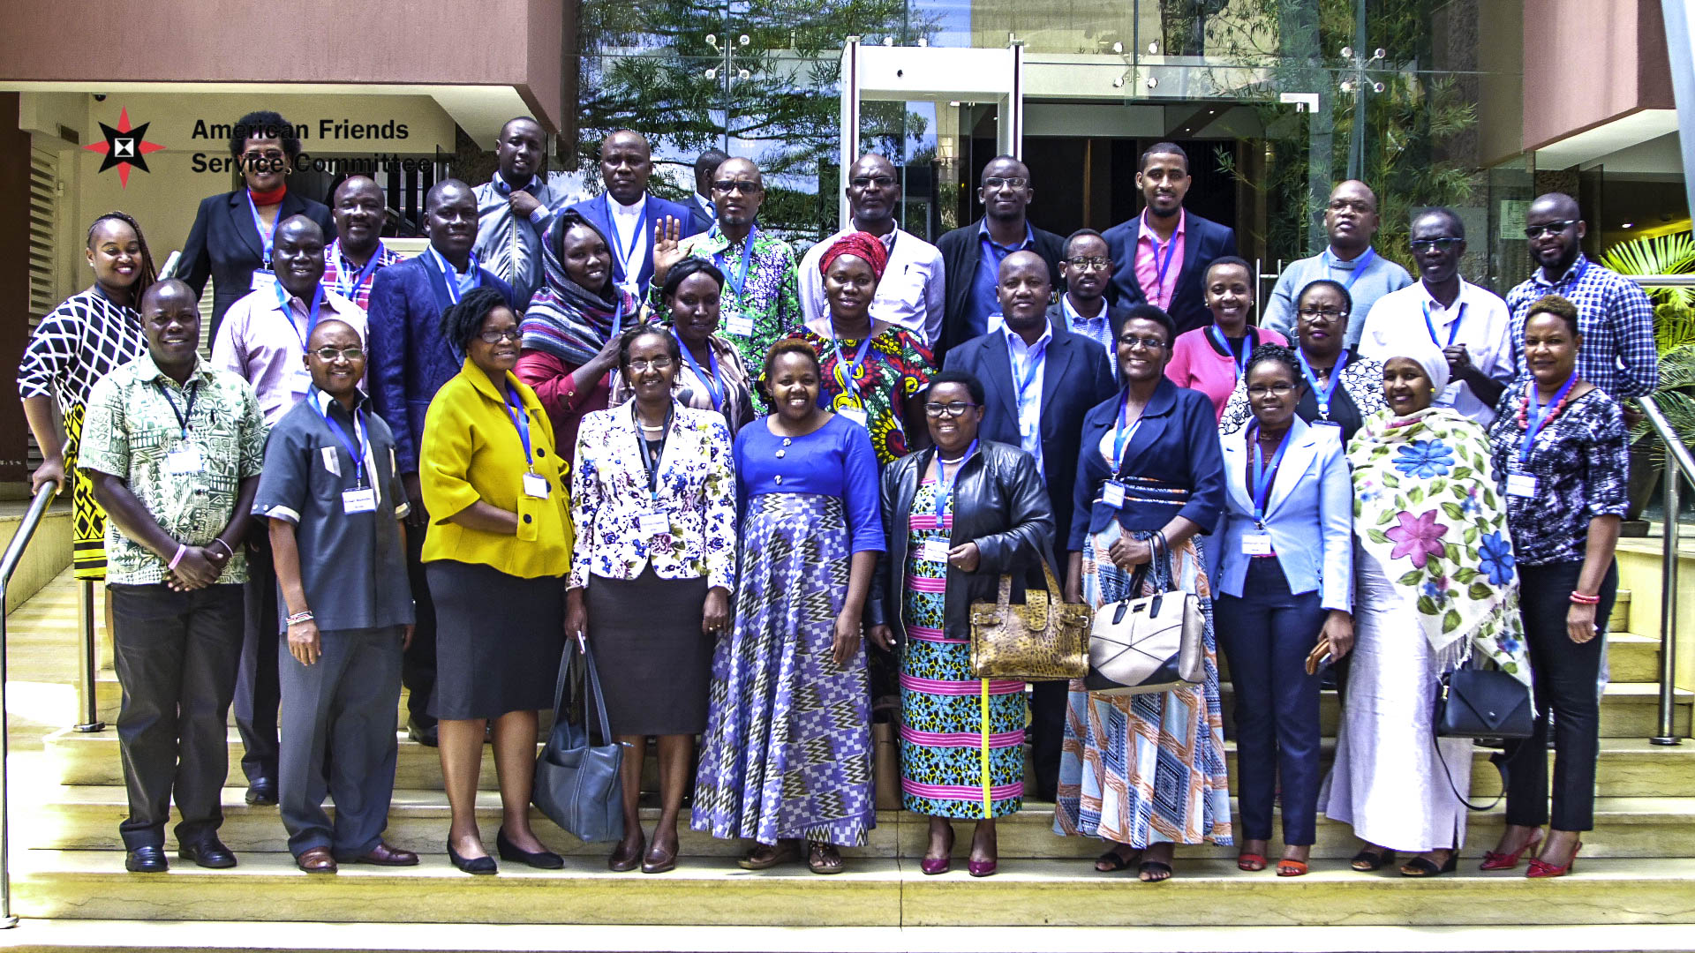

ACTIVITIES

Rape Survivors’ Support (RSS)

At the end of August 2019, 50 self-help groups for a total of 1180 women were functioning.

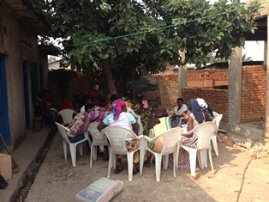

Caring for HIV Positive People (CHIVPP)
During this month of August 2019, medical follow up and home visits were done for our HIV positive people.
Maternity Ward Building
We are now finished with bricking the ground floor of the maternity ward building. The next step is building walls and pillars of the first floor.
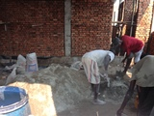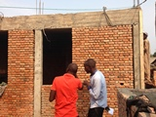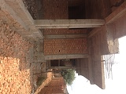
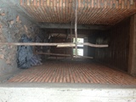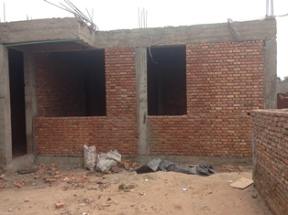
The bill of the next steps appears as follows:
- Pillars and bricking the first floor: $5800 ($3000 for bricking, and 2800 for pillars: $100/pillar)
- frame: $4,000
- 120 Iron Sheets: $2760 (23$/sheet)

Improving Women’s Reproductive Health (IWRH)
FWA community health workers and FWA staff have continued to mobilize people for HIV voluntary test and family planning.
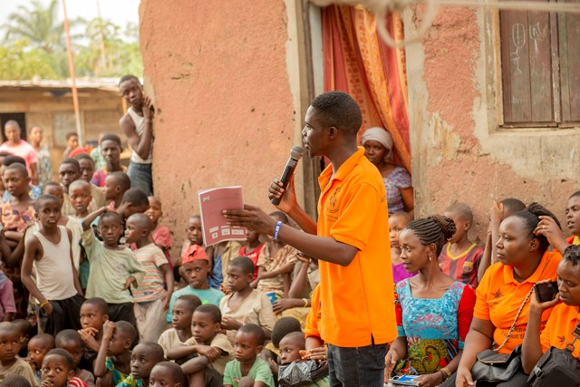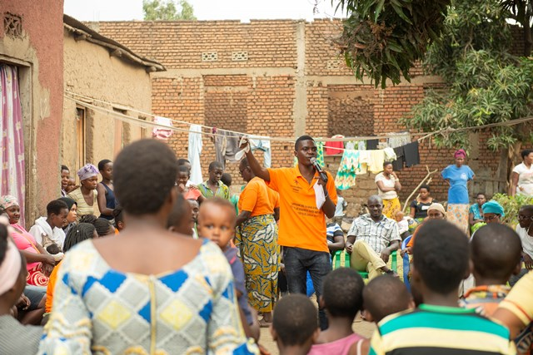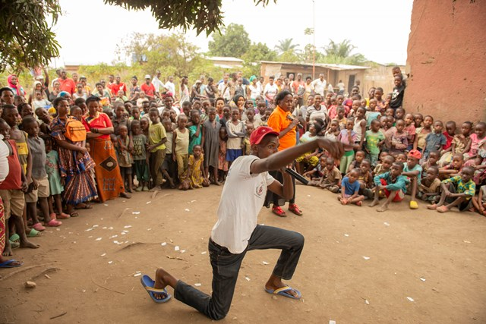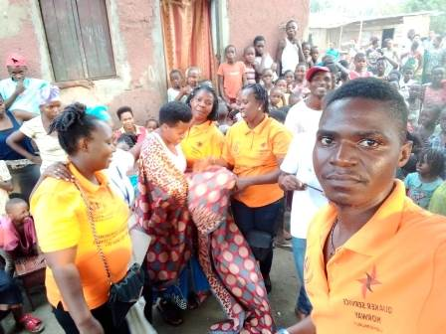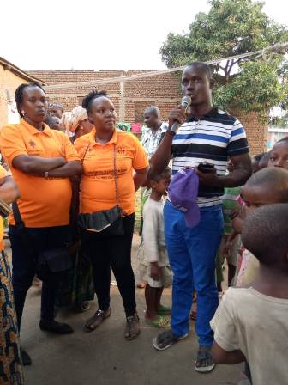
Action on Gender-Based Violence (AGBV)
Under the support of Quaker service Norway (QSN), a three-day retreat for 20 GBV accompanists was done at MIPAREC in Gitega province.
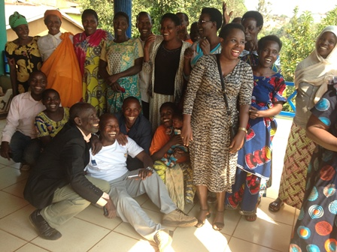
Under the support of the Canadian Friends Service Committee, one basic workshops on GBV were done for both religious leaders and community elected leaders on August 22-24, 2019. 20 participants attended the workshop. The venue was Commune Nyabiraba in Bujumbura province.
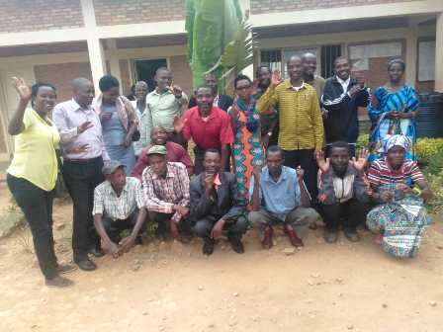

MEDICAL TEAM

CONSULTATIONS
123 cases were consulted by our medical doctors, including 75 adults (42women and 33 men), 14 children (6 girls and 8 boys) and 34 HIV positive people. The nurse received 226 patients including 175 adults and 51 children.

LABORATORY
In the month of August 2019, apart from HIV voluntary testing, there were a total of 127 tests.
Test | Test completed | Positive | Negative
G.E.  Malaria test | 11 | 4 | 7
Quick malaria test | 53 | 14 | 39
ECBU  Urine test | 6 | 6 | 0
Selles  Stool test | 14 | 13 | 1
Pregnancy | 13 | 2 | 11
Sero-widal  Typhoïd fever | 11 | 7 | 4
Glycémie  Diabetes | 5 | 4 | 1
RPR VDRL  (Syphillis) | 14 | 0 | 14
Complete Blood Count | 0 | 0 | 0
Total Tests: 127

Under the support of AGLI of the Friends Peace Teams, we were able to purchase a new microscope as the old one was become useless.
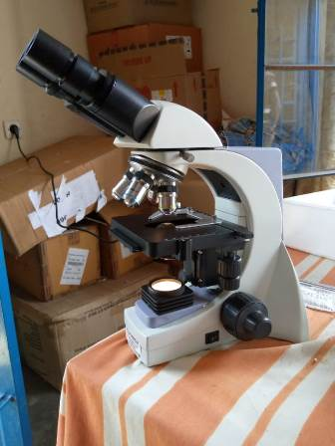

FAMILY PLANNING
357 people received contraceptives from FWA’s nurse, including 228 old cases and 129 new ones. 297 received the contraceptive injection, 40 were given pills, 1 received IUD, 16 received male condoms, 1 was given collar and 2 received implants.

PRENATAL CONSULTATION (PNC)
In the month of August 2019, 26 women came for prenatal consultation (PNC), including 12 who came for PNC 1, 7 for PNC 2 and 4 for PNC 3 and 1 for PNC 4

ANTI-RETROVIRAL SITE
At the end of August 2019, we had 321 patients under retro drugs followed at NTASEKA clinic, including 259 women and 62 men.

PHARMACY
Regarding medications, FWA was able to purchase the minimum needed medicine.

PSYCHOSOCIAL TEAM
In the month of August 2019, a total of 44 people received pre and post HIV test counseling and were tested for HIV. Out of the total number, 64% were women and among the six people detected HIV positive, five of them were women, with 18% of seropositivity. This high number is that we have now changed our strategy as required by the government. Actually, we target key populations, including sex workers, to do HIV test.
Total Number of People Tested: | 44
Total Number of Women Tested: | 28
% of People Tested Who Are Women: | 64%
Average Age: | 27
Median Age: | 26
Total HIV+ : | 6
Total HIV- : | 38
Number of Women HIV+ : | 5
Total % Seropositivity: | 14%
% of Women Tested Who Are HIV+: | 18%

