Friends Women’s Association
DECEMBER 2024 Report

Table of Content
FRIENDS WOMEN’S ASSOCIATION 1
DECEMBER 2024 REPORT 1
ACTIVITIES 2
CARING FOR HIV POSITIVE PEOPLE (CHIVPP) 2
IMPROVING WOMEN’S REPRODUCTIVE HEALTH (IWRH) 4
Rape Survivors’ Support (RSS) 4
MEDICAL TEAM 7
CONSULTATIONS 8
LABORATORY 8
FAMILY PLANNING 9
PRENATAL CONSULTATION (PNC) 9
ANTI-RETROVIRAL SITE 9
PHARMACY 9
PSYCHOSOCIAL TEAM 9

ACTIVITIES

Caring for HIV Positive People (CHIVPP)
In the month of December, medical follow-up and home visits were done for our HIV positive people. On December 1, 2024, the FWA joined the world to celebrate the international day against HIVAIDS.
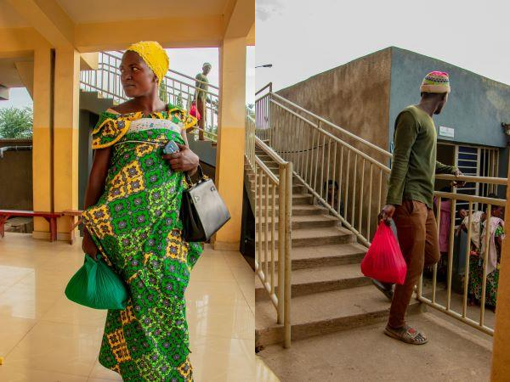

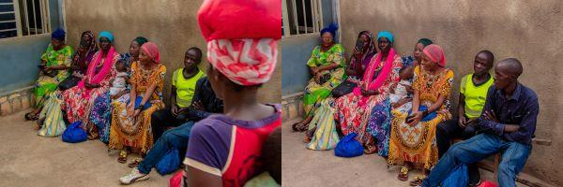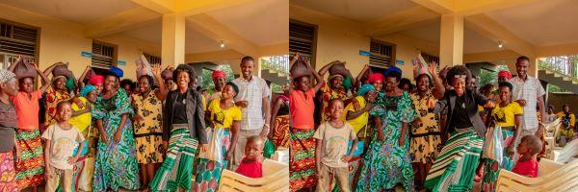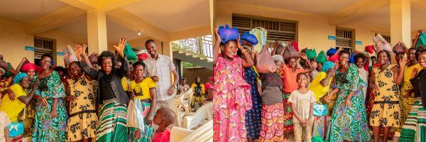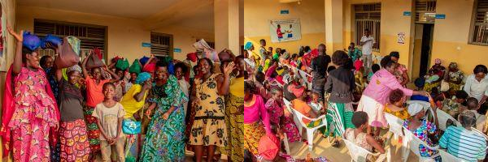

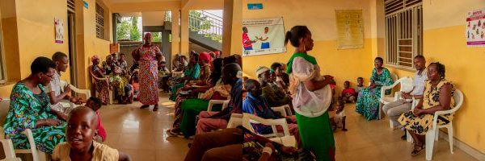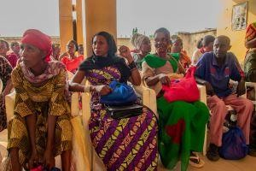

Maternity Ward Building

Although Ntaseka maternity ward still needs some medical equipment; both the delivery and them, hospitalization services are currently functional.

Improving Women’s Reproductive Health (IWRH)
FWA staff and FWA community health workers have continued to educate both men and women on the importance of family planning.

RAPE SURVIVORS’ SUPPORT (RSS)
- SELF HELP GROUPS (SHGS)

ABOUT NEW SHG
No | Name of SHG |  | Month of creation |  | Member Number | Created by
SHG Total Number: |  | 63

Evaluation

As the table shows, in the month December 6 SHGs were evaluated and the results are as follows;

No | About sharing | Number of SHG | Total
1 | Total money saved | 6 | 18,550,000
2 | Total Credit granted | 6 | 15,000,000
3 | Total interest | 6 | 8,800,000
4 | People who didn’t paid | 6 | 6
5 | Total money not refunded | 6 | 560,900

Classification of SHG

After evaluation it was found that;

Active | Less Active | Sick | Total
4 | 1 | 1 | 6

- Income-generating activities proposal

In December, a visit was made to Maramvya and Bubanza to discuss and identify potential income-generating activities that the beneficiaries of the HROC training are interested in pursuing. The goal is to support their unity and financial independence moving forward.

Bubanza: After the trauma healing workshop, facilitators encouraged the participants to form a cooperative. In response, 30 women came together, contributing 2000 Burundian francs each per month; today the cooperative has six months of contributions. The cooperative has proposed maize farming as an income-generating activity.

Maramvya: In Maramvya, a cooperative of 20 women was established before the training, as local leaders recognized this group as more effective than other groups within the Maramvya Friends Church. This cooperative has chosen rice farming as its income-generating activity.

THE WOMEN’S ECONOMIC EMPOWERMENT CENTER

The FWA has continued the construction work of the Women’s Socio Economic Empowement Center (WSEEC). The aim of this project is to avail training rooms and a temporary safe shelter for gender-based violence survivors at the FWA headquarters. This project will cost $200,000. We have so far mobilized $32,500 including $10,000 from The African Great Lakes Initiative of the Friends Peace Teams, $10,000 from the CFSC and
$12,500 from the Segal Family Foundation (SFF).
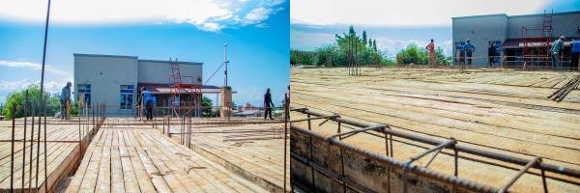
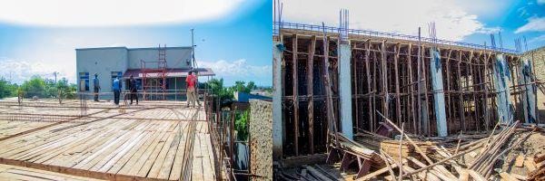
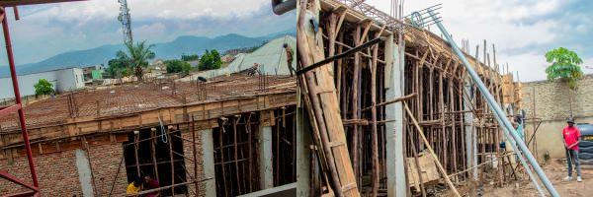

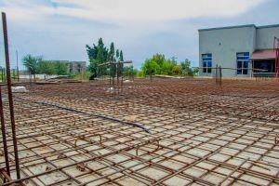

ACTION ON GENDER-BASED VIOLENCE (AGBV)

In the month of December, under the support of Quaker Service Norway (QSN) and the Canadian Friends Service Committee there were two public events during the 16 dys campaign of activism against GBV to be held respectively in Giheta commune in Gitega province and in Nabiraba commun ein Bujumbura province.
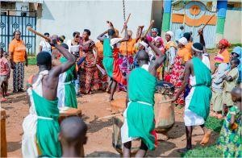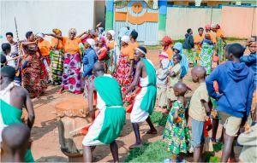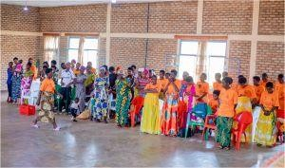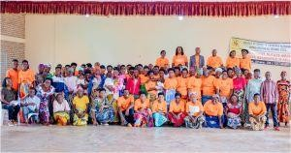

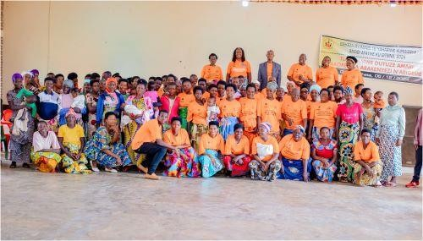

MEDICAL TEAM

CONSULTATIONS
Our medical doctors consulted with 157 cases, including 48 adults (18 men and 30 women), 18 children (4 boys and 14 girls), 34 HIV positive people and 57 pregnant women for ultrasound. The nurse received 308 patients including 227 adults and 81 children.

LABORATORY
In the month of December, apart from HIV voluntary testing, there were a total of 426 tests.

Test | Test completed | Positive | Negative
G.E.  Malaria test | 5 | 1 | 4
Quick malaria test | 128 | 34 | 94
ECBU  Urine test | 15 | 11 | 4
Selles Stool test | 1 | 1 | 0
Pregnancy | 45 | 11 | 34
Sero-widal Typhoïd fever | 59 | 9 | 50
Diabetes | 20 | 9 | 11
RPR VDRL (Syphilis) | 19 | 0 | 19
Complete Blood Count | 107 | 31 | 76
Hepatitis B | 7 | 0 | 7
Hepatitis C | 6 | 0 | 6
Viral Load | 14 | 3 | 11
Total Tests: 426

FAMILY PLANNING
561 People received contraceptives from FWA’s nurse, including 428 old cases and 133 new ones. 518 received the contraceptive injection, 20 received male condoms at Ntaseka clinic, 2 received UID and 21 received implants

PRENATAL CONSULTATION (PNC)
In December, 40 women came for prenatal consultation (PNC), including 14 who came for PNC 1, 12 for PNC 2, 9 for PNC 3 and 5 for PNC 4.
57 pregnant women came for the ultrasound test.

ANTI-RETROVIRAL SITE
At the end of December, we had 330 patients under retro drugs followed at NTASEKA clinic, including 267 women and 63 men.

PHARMACY
Regarding medications, FWA was able to purchase the minimum needed medicine.

PSYCHOSOCIAL TEAM
In the month of December, 91 people were tested for HIV and received pre and post HIV test counselling. All the 3 people detected HIV positive were women with 3% of seropositivity.

Total Number of People Tested: | 91
Total Number of Women Tested: | 71
% of People Tested Who Are Women: | 78%
Average Age: | 28
Median Age: | 28
Total HIV+ : | 3
Total HIV- : | 88
Number of Women HIV+ : | 3
Total % Seropositivity: | 3%
% of Women Tested Who Are HIV+: | 4%

PHOTOS LINK : https://drive.google.com/drive/folders/1Br5r3NvAFrqM5qB58oDJ- HQxgLpI7vdL?usp=sharing

